Merseyside schools

entry guide

accessing the on-line entry
☐ Go to www.mcsaa.org.uk and on the Current Events page click on the ENTER button
☐ This will open an entry page for the online entry system
☐ You can also download the Selection Letter and Championship Timetable on www.mcsaa.org.uk

On-line entry
☐ You will see a screen that has 2 drop down boxes. Use the left-hand box named ‘Event Club’ to select Merseyside Schools (see picture below)
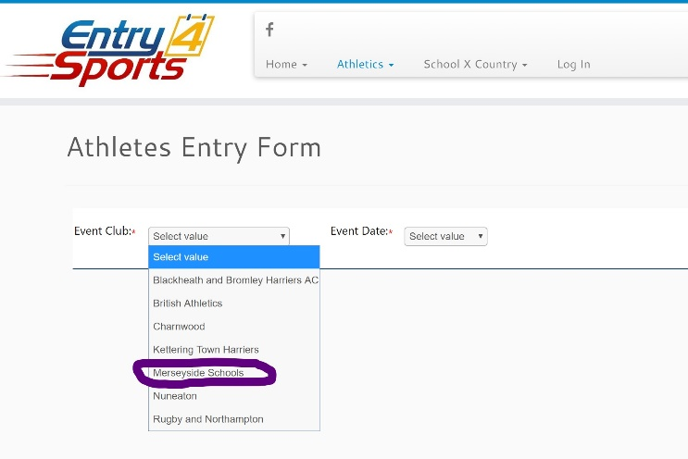

Entering your personal details
☐ You will see the new screen below
☐ If you ARE a member of an athletics club, enter your URN number in the box
☐ If you ARE NOT a member of an athletics club, just enter your first name and surname, and write unattached in the Club box
☐ Enter your school, your date of birth & your gender.
☐ Any athletes who are not in Secondary School will not be able to enter events
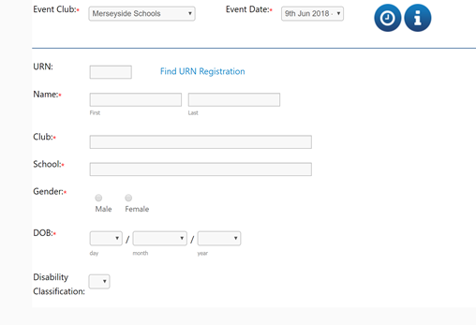

SElecting events
☐ Once you have completed your personal details, a list of events that you can enter will appear.
☐ You can select up to 2 events
☐ Once you have put in the details for your first event, click ‘add row’ to add another event
☐ Then tick the box accepting the Terms & Conditions
☐ Click Save and Go to Basket – only use the Add New Entry button if you are adding and paying for multiple athletes
☐ If you have selected 2 events, £1 will automatically be discounted at the checkout on the next page
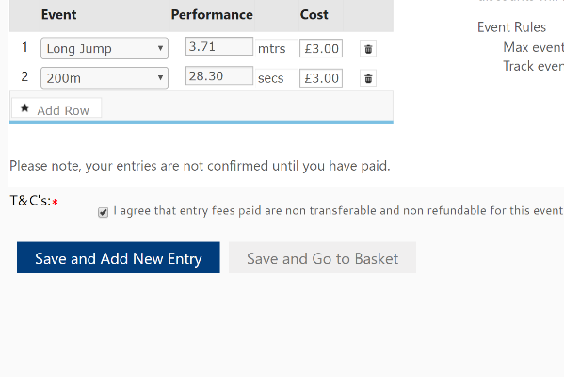

Common Questions
Q: How do I get help?
A: Click the ‘chat with us’ button on the bottom right of the screen
Q: I have completed my details but the next screen isn’t appearing
A: Make sure you have entered your information in every box that has a red star *
Q: Can I enter as an U11 even if I am in Year 6?
A: No, you must be in Secondary School, minimum age is Year 7
Q: When will I find out if I have been selected?
A: The Selection Committee will meet shortly after the Championships to select the teams. You will be notified by email after this meeting if you have been successful.

